My dear little Kitten,
I see little girls here almost every day, and every time I do, I think of you. I wish you were here with your Papa. If you were, I believe I could sleep so sweetly with you in my bed on the ground. I have a mattress, a comforter, and four blankets for my bed. I am often so tired that I lie down just as I am, without taking off my shirt or drawers, and sometimes without taking off my pants — though I usually do.
We have moved over to the west side of Salt River, and McCal and I each have new tents. Papa will try to tell you how our camp is laid out and describe his tent so you can see how comfortable it is.
The soldiers’ tents are in front, each holding about sixteen men. Their doors open into the company streets. Behind them are the kitchens where the men cook their dinners. Then come the tents of the company officers, and behind those the tents of the field officers. Still farther back are the kitchens and the servants’ tents.
Papa’s tent has two rooms. In the first room I have a box for a table and stools for our company. It is only for a short stay, so I will not keep it long. I want some shelves, but I must wait. Still, it is a nice room and makes me feel comfortable.
I wish you were here, my darling little girl.
Your loving Papa.
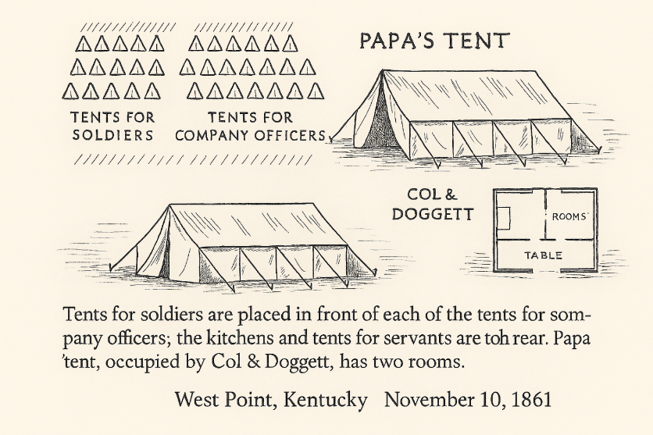
Girl — whose name was Lottie. She thought that was a pretty name for a little [illegible]. And I see little girls here most every day which makes me think of you. I wish you were here with your Papa. I think if you were here I could sleep so sweetly with you in my bed on the ground. I have a mattress and a comforter & four blankets for my bed. I was drowsy & wrapped — now I don’t bother them off nights — not my shirt nor drawers off. Sometimes I don’t take my pants off — but I usually do. I have got a nice tent now. We moved over to the west side of Salt River last Friday & McCal & each of us took some new tents. Papa will try to tell you how our camp is laid out & describe his tent. O you can see how comfortable it is.

